**PROJECT REPORT**

**Deep Learning Fundus Image Analysis for Early Detection of Diabetic Retinopathy**

**TEAM ID: PNT2022TMID39692**

**A PROJECT REPORT**

***Submitted by***

**510819104006            -        V.DURGA**

**510819104007            -        B.GOKUL**

**510819104020            -        A.SULOCHANA**

**510819104023            -        S.VINOBA**

***in partial fulfillment for the award of the degree***

***of***

**BACHELOR OF ENGINEERING**

**IN**

**COMPUTER SCIENCE AND ENGINEERIN**

**GANADIPATHY TULSIS JAIN ENGINEERING COLLEGE**

***TABLE OF CONTENT***

**1. INTRODUCTION**

**1.1 Project Overview**

**1.2 Purpose**

**2. LITERATURE SURVEY**

**2.1 Existing System**

**2.2 References**

**2.3 Problem Statement Definition**

**3. IDEATION & PROPOSED SOLUTION**

**3.1 Empathy Map Canvas**

**3.2 Ideation & Brainstorming**

**3.3 Proposed Solution**

**3.4 Problem Solution fit**

**4. REQUIREMENT ANALYSIS**

**4.1 Functional Requirement**

**4.2 Non-Functional Requirement**

**5. PROJECT DESIGN**

**5.1 Data Flow Diagram**

**5.2 Solution & technical Architecture**

**5.3 User Stories**

**6. PROJECT PLANNING & SCHEDULING**

**6.1 Sprint Planning & Estimation**

**6.2 Sprint Delivery Schedule**

**7. CODING & SOLUTIONING**

**7.1 Feature 1**

**7.2 Feature 2**

**8. TESTING**

**8.1 Test Cases**

**8.2 User Acceptance Testing**

**9. RESULT**

**9.1 Performance Metrics**

**10. ADVANTAGES & DISADVANTAGES**

**11. CONCLUSION**

**12. FUTURE SCOPE**

**13. APPENDIX**

**Source Code**

**GitHub & Project Demo Link**

**INTRODUCTION**

* 1. **Project Overview**

Diabetic Retinopathy (DR) is a common complication of diabetes mellitus, which causes lesions on the retina that affect vision. If it is not detected early, it can lead to blindness. Unfortunately, DR is not a reversible process, and treatment only sustains vision. DR early detection and treatment can significantly reduce the risk of vision loss. The manual diagnosis process of DR retina fundus images by ophthalmologists is time, effort and cost-consuming and prone to misdiagnosis unlike computer-aided diagnosis systems.

Transfer learning has become one of the most common techniques that has achieved better performance in many areas, especially in medical image analysis and classification.

We used Transfer Learning techniques like Inception V3,Resnet50,Xception V3 that are more widely used as a transfer learning method in medical image analysis and they are highly effective.

**1.2 Purpose**

The main purpose of this project is to detect the DR in early stage to avoid premanent blindness.

While blindness from diabetes is permanent, the good news is that it is almost completely preventable—especially if diabetic patients receive an annual diabetic eye exam. Early detection and treatment of diabetic retinopathy is key and **reduces the risk of severe vision loss by 90%**.

**LITERATURESURVEY**

**2.1 Existing System**

**Survey 1 :**

**AUTHORS:** Mohammed Z. Atwany , Abdulwahab H. Sahyoun , And Mohammad Yaqub (March 22).

**TITLE:** ‘Deep Learning Techniques for Diabetic

Retinopathy Classification: A Survey.’

**METHODS:** This paper reviews and analyzes state-of-the-art deep learning methods in supervised, self-supervised, and Vision Transformer setups, proposing retinal fundus image classification and detection. For instance, referable, non-referable, and proliferative classifications of Diabetic Retinopathy are reviewed and summarized. Moreover, the paper discusses the available retinal fundus datasets for Diabetic Retinopathy that are used for tasks such as detection, classification, and segmentation.

**Survey 2 :**

**AUTHORS:** Mohammed Hazim Johari , Hasliza Abu Hassan , Ahmad Ihsan Mohd Yassin (July 2018).

**TITLE:** ‘Early Detection of Diabetic Retinopathy by Using Deep Learning Neural Network.’

**METHODS:** This project presents a method to detect diabetic retinopathy on the fundus images by using deep learning neural network. Convolution Neural Network (CNN) has been used in the project to ease the process of neural learning. The data set used were retrieved from MESSIDOR database and it contains 1200 pieces of fundus images. The images were filtered based on the project needed. There were 580 pieces of images types has been used after filtered and those pictures were divided into 2, which is Exudates images and Normal images. On the training and testing session, the 580 mixed of exudates and normal fundus images were divided into 2 sets which is training set and testing set. The result of the training and testing set were merged into a confusion matrix. The result for this project shows that the accuracy of the CNN for training and testing set was 99.3% and 88.3% respectively.

**Survey 3 :**

**AUTHOR:** Recep Emre Hacisoftaoglu (Dec 2019).

**TITLE:** ‘Deep Learning Frameworks For Diabetic Retinopathy Detection Using Smartphone-Based Retinal Imaging Systems.’

**METHODS:** In this thesis, we first investigate the smartphone-based portable ophthalmoscope systems available on the market and compare their Field of View and image quality to determine if they are suitable for Diabetic Retinopathy detection during a general health screening. Then, we propose automatic Diabetic Retinopathy detection algorithms for smartphone-based retinal images using deep learning frameworks, AlexNet and GoogLeNet. To test our proposed methods, we generate smartphone-based synthetic retina images by simulating the different Field of View with masking the original image around the optic disk and cropping .

**Survey 4 :**

**AUTHORS:** Lei Lu , Ying Jiang , Ravindran Jaganathan , and Yanli Hao. (Jan 2019).

**TITLE:** ‘Current Advances in Pharmacotherapy and Technology for Diabetic Retinopathy: A Systematic Review.’

**METHODS:** Direct injections or intra virtual anti-inflammatory and anti angiogenesis agents are widely used pharmacotherapy to effectively treat DR and diabetic macular edema (DME). However, their effectiveness is short term, and the delivery system is often associated with adverse effects, such as cataract and increased intraocular pressure. Further, systemic agents and plants-based drugs have also provided promising treatment in the progression of DR. Recently, advancements in pluripotent stem cells technology enable restoration.

**Survey 5 :**

**AUTHORS:** Obaida M. Al-Hazaimeh , Bassam Al-Naami , Khalid M.O. Nahar ( 2018 ).

**TITLE:** ‘An effective image processing method for detection of diabetic retinopathy diseases from retinal fundus images.’

**METHODS:** The current state-of-the-art techniques are not satisfied with sensitivity and specificity. In fact, there are still other issues to be resolved in state-of-the-art techniques such as performances, accuracy, and easily identify the DR disease effectively. Therefore, this paper proposes an effective image processing method for detection of diabetic retinopathy diseases from retinal fundus images that will satisfy the performance metrics (i.e.,sensitivity, specificity, accuracy). The proposed automatic screening system for diabetic retinopathy was conducted in several steps: Pre-processing, optic disc detection and removal, blood vessel segmentation and removal, elimination of fovea, feature extraction (i.e., Micro-aneurysm, retinal hemorrhage, and exudates), feature selection and classification. Finally, a software-based simulation using MATLAB was performed using DIARETDB1 dataset and the obtained results are validated by comparing with expert ophthalmologists. The results of the conducted experiments showed an efficient and effective in sensitivity, specificity and accuracy.

**2.2 References**

1. Mohammad Z. Atwany , Abdulwahab H. Sahyoun , And Mohammad Yaqub, 2022, ‘Deep Learning Techniques for Diabetic Retinopathy Classification: A Survey.’
2. Mohamad Hazim Johari , Hasliza Abu Hassan , Ahmad Ihsan Mohd Yassin, 2018, ‘Early Detection of Diabetic Retinopathy by Using Deep Learning Neural Network.’
3. Recep Emre Hacisoftaoglu, 2019, ‘Deep Learning Frameworks For Diabetic Retinopathy Detection Using Smartphone-Based Retinal Imaging Systems.’
4. Lei Lu , Ying Jiang , Ravindran Jaganathan , and Yanli Hao, 2019, ‘Current Advances in Pharmacotherapy and Technology for Diabetic Retinopathy: A Systematic Review.’
5. Obaida M. Al-Hazaimeh , Bassam Al-Naami , Khalid M.O. Nahar, 2018 , ‘An effective image processing method for detection of diabetic retinopathy diseases from retinal fundus images.’

**2.3 Problem Statement Definition**

Diabetic Retinopathy (DR) is a common complication of diabetes mellitus, which causes lesions on the retina that affect vision. If it is not detected early, it can lead to blindness. Unfortunately, DR is not a reversible process, and treatment only sustains vision. DR early detection and treatment can significantly reduce the risk of vision loss.

|  |  |
| --- | --- |
| **Who does the problem affect?** | Anyone with type 1 diabetes or type 2 diabetes |
| **What are the boundaries of the problem?** | Increase in blood sugar is, the most important reason to develop this eye complication. |
| **What is the issue?** | * Blindness. * Spots or dark strings floating in your vision. * Dark or empty areas in vision |
| **When does the issue occur?** | An abnormal rise in diabetic levels |
| **Where does the issue occur?** | Diabetic retinopathy is a complication of diabetes, caused by high blood sugar levels damaging the back of the eye, then a leak in small amount of blood into your retinas. |
| **Why is it important that we fix the problem?** | If it is not detected early, it can lead to blindness. Unfortunately, diabetic retinopathy is not a reversible process, and treatment only sustains vision |
| **How to solve this issue?** | The detection of this DR in early stages manually is a difficult task. Since a Deep learning techniques are used for early detection of diabetic retinopathy that can prevent blindness and other eye related diseases |

**IDEATION & PROPOSED SOLUTION**

**3.1 Empathy Map Canvas**

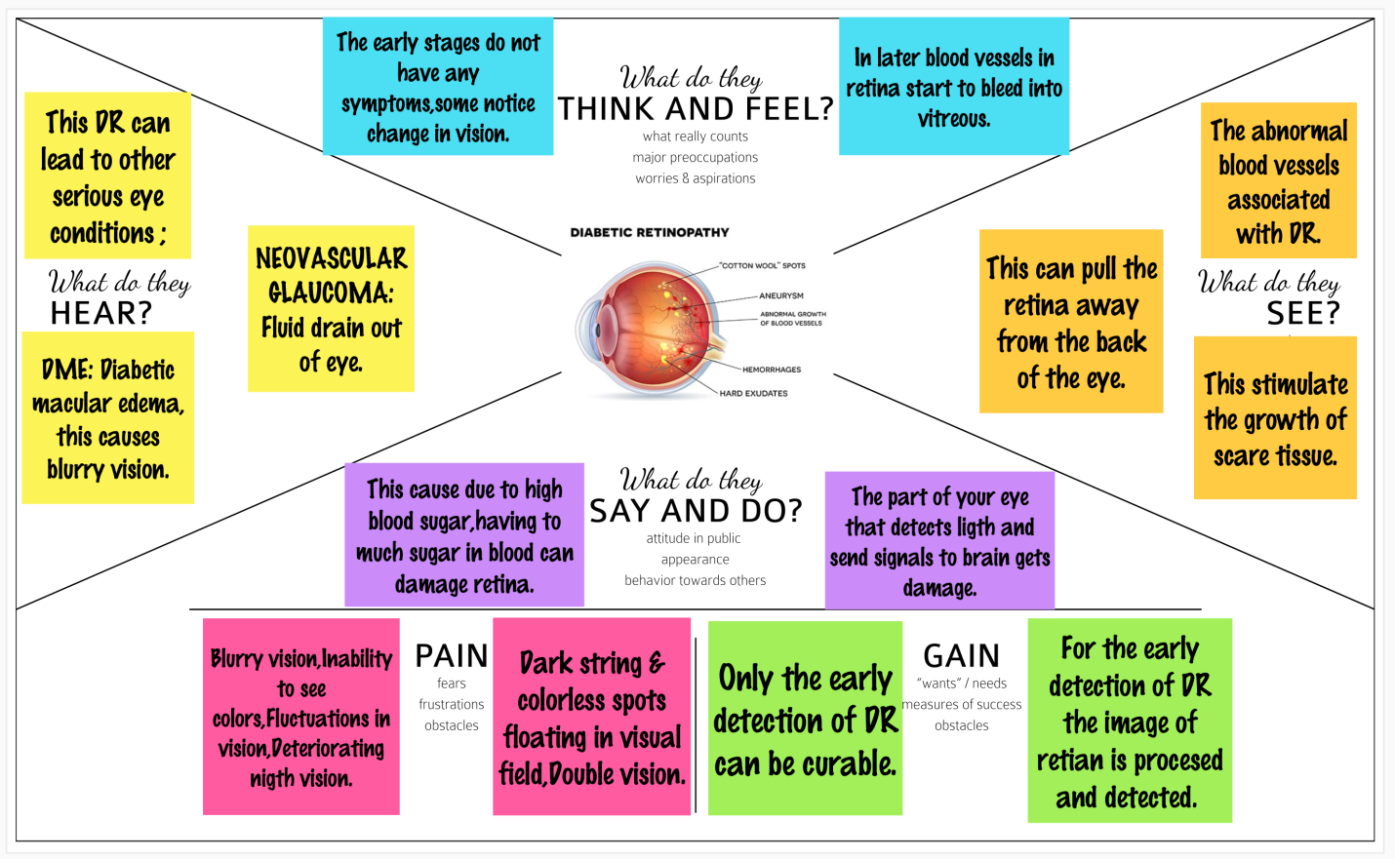

**3.2 Ideation & Brainstorming**

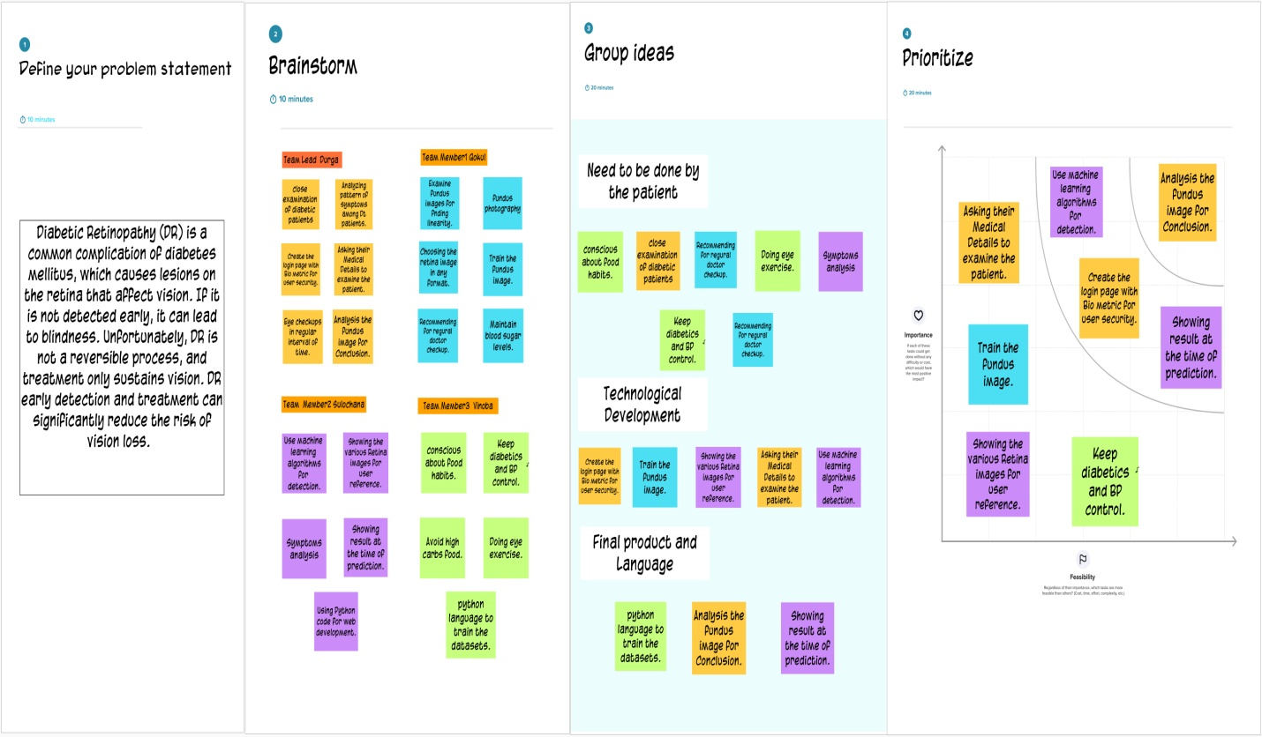

**3.3 Proposed Solution**

|  |  |  |
| --- | --- | --- |
| **S.No.** | **Parameter** | **Description** |
| 1. | Problem Statement | Diabetic Retinopathy (DR) is a common complication of diabetes mellitus, DR mutilates the retinal blood vessels of a patient having diabetes.  This causes damages to retinal blood vessels which lead to imperfect vision and **if it is not detected early stages , it can lead to blindness.**  The early stage of DR **does not have any Symptoms,** so it is important to identify microaneurysms and hemorrhages to detect the early stage of DR.  Unfortunately, DR is not a reversible process DR early detection and treatment can significantly reduce the risk of vision loss. |
| 2. | Idea/Solution description | **Existing methods are lacking in the earlier detection.** Because preprocessing techniques used in those methods are not effective to analyze such smaller features.  We opt to use multi-layer neural networks as deep Neural network.  In the fact that data is Image, the best type of neural network that we use to process is Convolutional Neural Networks.  First the **data preprocessing** is done to the images (our dataset) it is highly recommended, For better accuracy to be achieved.  As we have to do for most of the data, **normalization** plays an important role in our process.  After preprocessing and **normalizing,** the prepared dataset could be used as input to our deep convolutional neural network.  Then deep NN will run and fit our data and then the result will be produced by that. This report will cover steps how this deep convolutional network to be implemented |
| 3. | Novelty / Uniqueness | One of the most important decision had to be made is which programming language can be used for satisfying our goal for extracting knowledge from our data. The suitable programming language is **Python**. Because it has ,a lot of tools and framework to create a strong ANN.  **IBM Waston** is also use to predict the future outcomes, automate complex processes and optimize user’s time.  The result accuracy can so be increased from the existing codes which are proposed. |
| 4. | Social Impact / Customer Satisfaction | This may help the Diabetic patient to detect DR in early stages by health camps and in regular interval of checkup with their retinal images. |
| 5. | Business Model (Revenue Model) | Can be collaborated with the **Diabetics Diagnosis center** for regular check up.  Government camps and NGO healthcare camps can be conducted for awareness |
| 6. | Scalability of the Solution | The project will help as to detect DR more prominently then the existing system. It can also produce a result with specific stage of Diabetic Retinopathy. |

**3.4 Problem Solution fit**

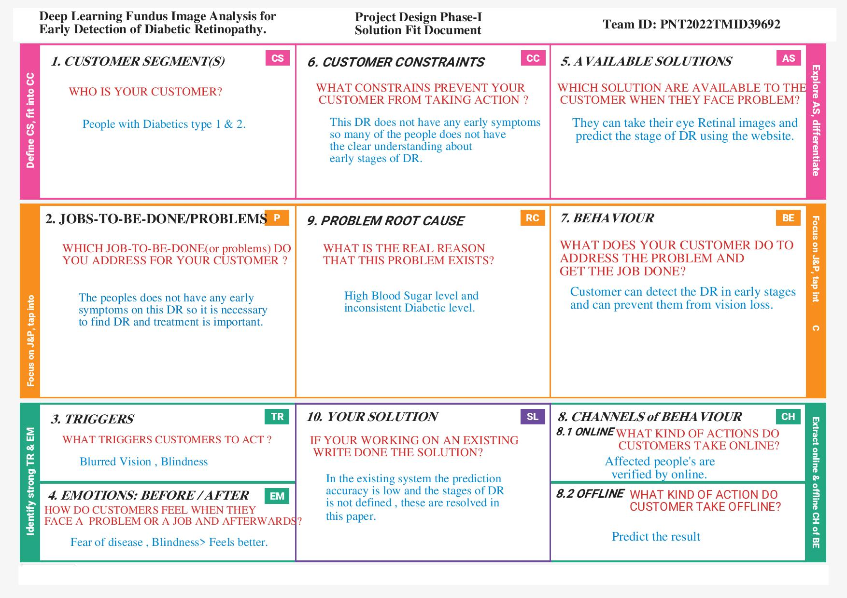

**REQUIREMENT ANALYSIS**

**4.1 Functional requirement**

|  |  |  |
| --- | --- | --- |
| **FR No.** | **Functional Requirement (Epic)** | **Sub Requirement (Story / Sub-Task)** |
| FR-1 | User Registration | The user can register to the website through either email id or phone number with new password for their account. |
| FR-2 | User Login | The existing user can directly login to the site by giving the Login credentials. |
| FR-3 | Admin Login | The Admin can login to the site where he/she can find the analysis to the predicted data. |
| FR-4 | Upload Image | The user can upload the eye retina image in the dropdown box from various resources like(google drive, gallery etc.,) |
| FR-5 | Data collection | Collect the dataset related to the DR from source to Train the Model. |
| FR-6 | Creating Model | Create the model and Train the model from the dataset for prediction. |
| FR-7 | Test the Model | Test the model for prediction. |
| FR-8 | Diagnosis | Get diagnosis result on the application and follow up with treatments. |

**4.2 Non-Functional requirements**

|  |  |  |
| --- | --- | --- |
| **NFR No.** | **Non-Functional Requirement** | **Description** |
| NFR-1 | **Usability** | The product must be easily usable by any type of users( literate and illiterate),the people how are old and affected by DR can also use this tool for Diagnosis. |
| NFR-2 | **Security** | Data security is important to store the customer data in the secured manner. The information should not be leaked outside. |
| NFR-3 | **Reliability** | Should provide novel results for five different screening and clinical grading systems for diabetic retinopathy including state-of-the-art results for accurately classifying images according to clinical five-grade diabetic retinopathy. |
| NFR-4 | **Performance** | The ability of Deep Learning is to perform pattern recognition by creating complex relationships based on input data and then comparing it with performance standards is a big step also to diagnosis in short time. |
| NFR-5 | **Availability** | Healthcare affordability, quality, and accessibility is made easier using this technology and The product must be available to all kinds of users. |
| NFR-6 | **Scalability** | The product must hold stable even when multiple users are using it at the same times. |

**PROJECT DESIGN**

**5.1 Data Flow Diagrams**

**Simplified Flow :**

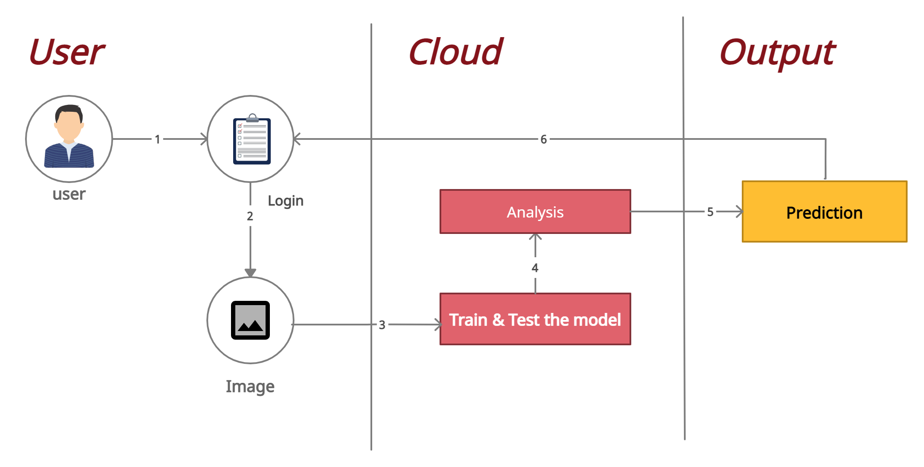

**User :**

1. New user register to the website , Existing user Login site directly.
2. The User upload the photo image of Eye Retina.

**Cloud :**

1. Training the Module is done.
2. Analysis is done with the Images.

**Output :**

1. Prediction is done with the Uploaded images.
2. Output is displayed in User Interface.

**Data Flow Diagrams:**

A Data Flow Diagram (DFD) is a traditional visual representation of the information flows within a system. A neat and clear DFD can depict the right amount of the system requirement graphically. It shows how data enter and leaves the system, what changes the information, and where data is stored.

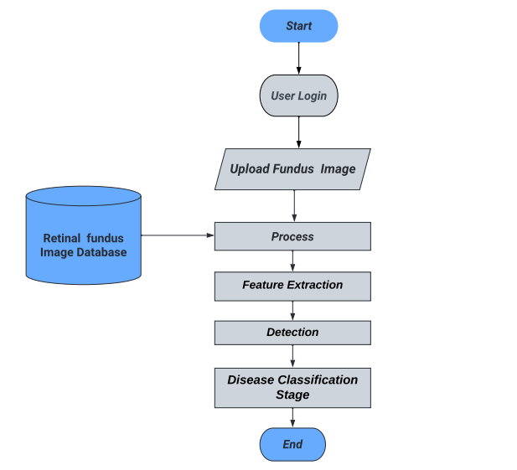

**5.2 Solution & Technical Architecture**

**TECHNICAL ARCHITECTURE:**

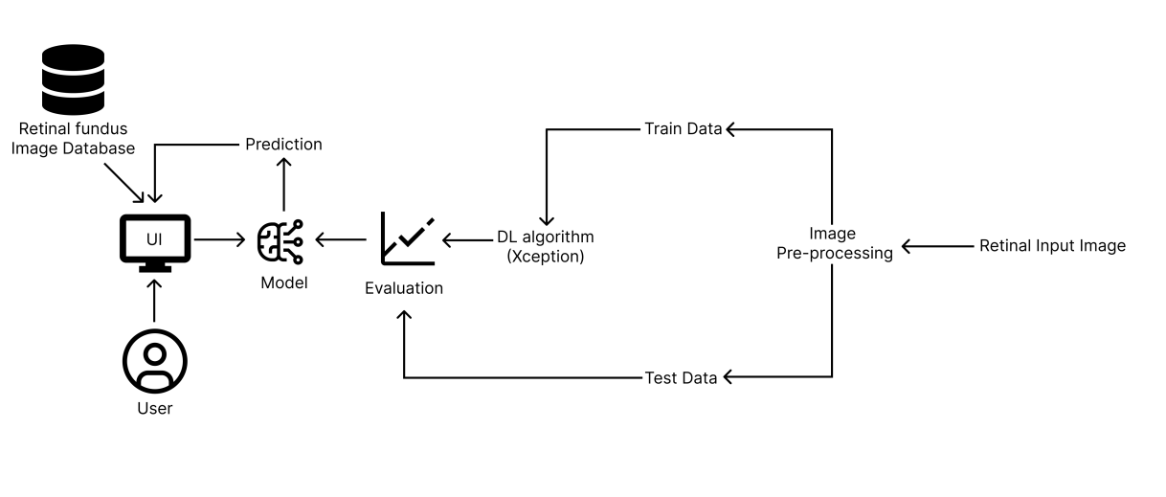

**Table-1 : Components & Technologies:**

|  |  |  |  |
| --- | --- | --- | --- |
| **Sn.No.** | **Component** | **Description** | **Technology** |
| 1. | User Interface | How user interacts with application e.g. Web UI, Mobile App, Chat box etc. | HTML, CSS, JavaScript etc. |
| 2. | Application Logic-1 | Logic for a process in the application. | Python, Flask. |
| 3. | Database | Data Type, Configurations etc. | MySQL, NoSQL, etc. |
| 4. | Cloud Database | Database Service on Cloud | IBM DB2, IBM Cloudant etc. |
| 5. | Machine Learning Model | Machine Learning Model | Diabetic Retinopathy detection |
| 6. | Infrastructure (Server / Cloud | Application Deployment on Local System / Cloud Local Server Configuration | IBM Cloud |

**Table-2: Application Characteristics:**

|  |  |  |  |
| --- | --- | --- | --- |
| **S.No** | **Characteristics** | **Description** | **Technology** |
| **1.** | Open-Source Frameworks | List the open-source frameworks used | Flask, TensorFlow. Keras. Numpy, Pandas |
| **2** | Security Implementations | List all the security / access controls implemented, use of firewalls etc. | Built-in protection. |
| **3** | Scalable Architecture | Justify the scalability of architecture (3 – tier, Micro-services) | 3-tiers. |
| **4** | Availability | Justify the availability of applications (e.g. use of load balancers, distributed servers etc.) | Load balancer |
| **5** | Performance | Design consideration for the performance of the application (number of requests per sec, use of Cache, use of CDN’s) etc. | It depends upon the input images |

**SOLUTION ARCHITECTURE**

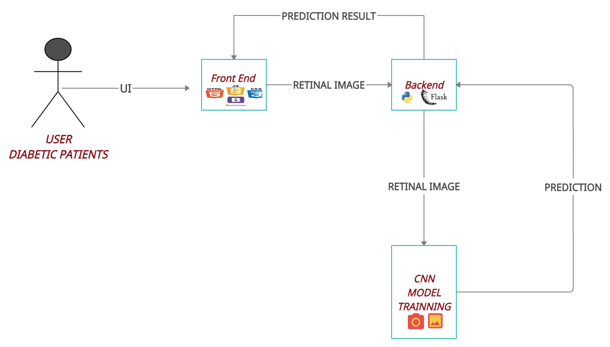

**5.3 User Stories**

| **User Type** | **Functional Requirement (Epic)** | **User Story Number** | **User Story / Task** | **Acceptance criteria** | **Priority** | **Release** |
| --- | --- | --- | --- | --- | --- | --- |
| Common User | Dashboard | USN-1 | As a user, I must be able to upload image of my eyes | I can upload or take image | High | Sprint-1 |
|  |  | USN-2 | As a user, I will receive the diagnosis result whether I have retinopathy or not. | I can receive the diagnosis | High | Sprint-1 |
|  |  | USN-3 | As a user, I receive the severity of the retinopathy | I can receive the severity of the retinopathy | Medium | Sprint-2 |
|  |  | USN-4 | As a user, I can receive the suggested remedy | I can receive the suggested remedy | Medium | Sprint-2 |

**PROJECT PLANNING & SCHEDULING**

**6.1 Sprint Planning & Estimation**

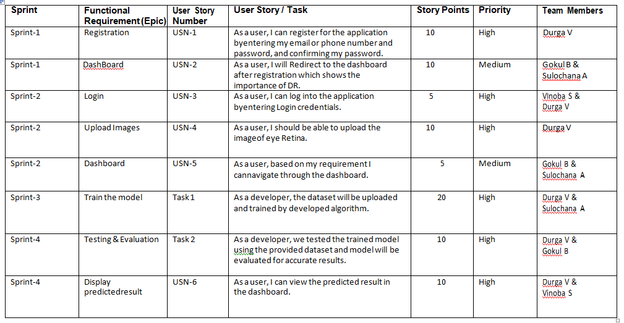

**6.2 Sprint Delivery Schedule**

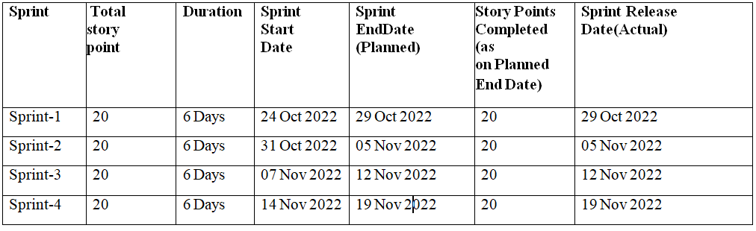

**Velocity:**

Imagine we have a 10-day sprint duration, and the velocity of the team is 20 (points per sprint). Let’s calculate the team’s average velocity (AV) per iteration unit (story points per day).

AV=20/6=3.33points per day.

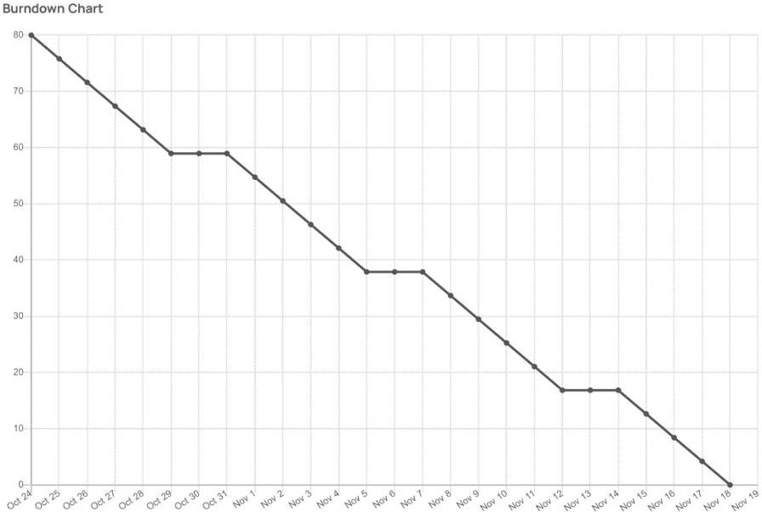**Burn Down Chart**

**6.3 Reports from JIRA**

**SPRINT 1**

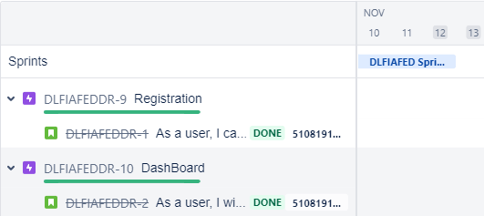

**SPRINT 2**

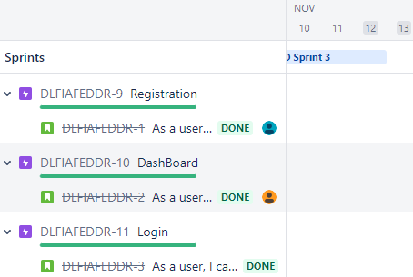

**SPRINT 3**

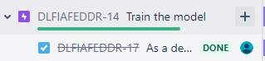

**SPRINT 4**

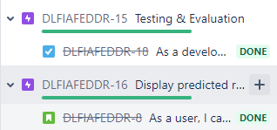

**CODING & SOLUTIONING**

**7.1 Feature 1 : Home Page with DR details.**

As a user I will know about the different Stages of Diabetic Retinopathy, and User can navigate Register and login using the home page.

**Index.html**

<!DOCTYPE html>  
<html lang="en">  
<head>  
 <meta charset="UTF-8">  
 <title>index</title>  
 <link rel="stylesheet" href="..\static\css\indexstyle.css">  
</head>  
<body>  
 <div class="main">  
 <nav>  
 <div class ="logo">  
 <img src="..\static\images\img.png">  
 </div>  
 <div class="nav-links">  
 <ul>  
 <li><a href="index.html">Home</a></li>  
 <li><a href="login">Login</a></li>  
 <li><a href="register">Register</a></li>  
 <li><a href="prediction">Prediction</a></li>  
 </ul>  
 </div>  
 </nav>  
  
 <div class="information">  
 <div class="overlay"></div>  
 <img src="..\static\images\myproject.jpg" class="eye">  
 <div id="circle">  
 <div class="stages one">  
 <img src="..\static\images\text-1.png">  
 <div>  
 <h1>NPDR</h1>  
 <p>Mild Swelling in Retinal!</p>  
 </div>  
 </div>  
 <div class="stages two">  
 <img src="..\static\images\text-2.png">  
 <div>  
 <h1>Moderate NPDR</h1>  
 <p>NPDR plus small bleeds in Retinal!</p>  
 </div>  
 </div>  
 <div class="stages three">  
 <img src="..\static\images\text-3.png">  
 <div>  
 <h1>Severe NPDR</h1>  
 <p>Moderate NPDR plus further damage to<br>  
 blood vessels in Retinal!</p>  
 </div>  
 </div>  
 <div class="stages four">  
 <img src="..\static\images\text-4.png">  
 <div>  
 <h1>PDR</h1>  
 <p>Severe NPDR plus new Vessel<br>  
 formation in Retinal!</p>  
 </div>  
 </div>  
 </div>  
 </div>  
 <div class="coltrols">  
 <img src="..\static\images\arrow.png" id="upBtn">  
 <h3>Different Stages of DR</h3>  
 <img src="..\static\images\arrow.png" id="downBtn">  
 </div>  
  
 </div>  
 <script>  
 var circle = document.getElementById("circle");  
 var upBtn = document.getElementById("upBtn");  
 var downBtn = document.getElementById("downBtn");  
  
 var rotateValue = circle.style.transform;  
 var rotateSum;  
  
 upBtn.onclick = function()  
 {  
 rotateSum = rotateValue + "rotate(-90deg)";  
 circle.style.transform = rotateSum;  
 rotateValue = rotateSum;  
 }  
 downBtn.onclick = function()  
 {  
 rotateSum = rotateValue + "rotate(90deg)";  
 circle.style.transform = rotateSum;  
 rotateValue = rotateSum;  
 }  
 </script>  
  
</body>  
</html>

**7.2 Feature 2 : Login and Register.**

The new users can Register and existing user can login to the page to check the DR classification.

Login.html

<!DOCTYPE html>  
<html lang="en">  
<head>  
 <meta charset="UTF-8">  
 <title>Login</title>  
 <link href="..\static\css\RLStyle.css" rel="stylesheet">  
</head>  
  
<body><div class="hero">  
 <nav>  
 <div class ="logo">  
 <img src="..\static\images\img.png">  
 </div>  
 <div class="nav-links">  
 <ul>  
 <li><a href="index.html">Home</a></li>  
 <li><a href="register">Register</a></li>  
 </ul>  
 </div>  
 </nav>  
  
  
 <div class="information">  
 <div class="overlay"></div>  
 <img src="..\static\images\myproject.jpg" class="eye">  
 </div>  
  
  
 <div class="form-box">  
 <div class="button-box">  
 <div id="btn"></div>  
 <button type="button" class="toggle-btn" onclick="login()">Login</button>  
 <button type="button" class="toggle-btn" onclick="register()">Register</button>  
 </div>  
 <div class="social-icons">  
 <img src="..\static\images\fb.png">  
 <img src="..\static\images\gp.png">  
 <img src="..\static\images\tw.png">  
 </div>  
 <form action="afterlogin" method="post" id="Login" class="input-group">  
 <input type="email" class="input-field" name="_id" placeholder="Enter Email ID" required>  
 <input type="password" class="input-field" name="psw" placeholder="Enter Password" required>  
 <input type="checkbox" class="check-box"><span>Remember Password</span>  
 <button type="submit" class="submit-btn">Login</button>  
 {{pred}}  
 </form>  
 <form action="afterreg" method="post" id="Register" class="input-group">  
 <input type="text" class="input-field" name="name" placeholder="User Name " required>  
 <input type="email" class="input-field" name="_id" placeholder="Enter your Email" required>  
 <input type="password" class="input-field" name="psw" placeholder="Enter Password" required>  
 <input type="checkbox" class="check-box"><span>I agree to the terms and conditions</span>  
 <button type="submit" class="submit-btn">Register</button>  
 {{pred}}  
 </form>  
 </div>  
 </div>  
  
 <script>  
 var x = document.getElementById("Login");  
 var y = document.getElementById("Register");  
 var z = document.getElementById("btn");  
  
 function register(){  
 x.style.left = "-400px";  
 y.style.left = "50px";  
 z.style.left = "110px";  
 }  
 function login(){  
 x.style.left = "50px";  
 y.style.left = "450px";  
 z.style.left = "0";  
 }  
 </script>  
</body>  
</html>

Register.html

<!DOCTYPE html>  
<html lang="en">  
<head>  
 <meta charset="UTF-8">  
 <title>Register</title>  
 <link href="..\static\css\RLStyle.css" rel="stylesheet">  
</head>  
<body><div class="hero">  
 <nav>  
 <div class ="logo">  
 <img src="..\static\images\img.png">  
 </div>  
 <div class="nav-links">  
 <ul>  
 <li><a href="index.html">Home</a></li>  
 <li><a href="login">Login</a></li>  
 </ul>  
 </div>  
 </nav>  
  
  
 <div class="information">  
 <div class="overlay"></div>  
 <img src="..\static\images\myproject.jpg" class="eye">  
 </div>  
  
  
  
 <div class="form-box">  
 <div class="button-box">  
 <div id="btn"></div>  
 <button type="button" class="toggle-btn" onclick="login()">Login</button>  
 <button type="button" class="toggle-btn" onclick="register()">Register</button>  
 </div>  
 <div class="social-icons">  
 <img src="..\static\images\fb.png">  
 <img src="..\static\images\gp.png">  
 <img src="..\static\images\tw.png">  
 </div>  
 <form action="afterlogin" method="post" id="Login" class="input-group">  
 <input type="email" class="input-field" name="_id" placeholder="Enter Email ID" required>  
 <input type="password" class="input-field" name="psw" placeholder="Enter Password" required>  
 <input type="checkbox" class="check-box"><span>Remember Password</span>  
 <button type="submit" class="submit-btn">Login</button>  
 {{pred}}  
 </form>  
 <form action="afterreg" method="post" id="Register" class="input-group">  
 <input type="text" class="input-field" name="name" placeholder="User Name " required>  
 <input type="email" class="input-field" name="_id" placeholder="Enter your Email" required>  
 <input type="password" class="input-field" name="psw" placeholder="Enter Password" required>  
 <input type="checkbox" class="check-box"><span>I agree to the terms and conditions</span>  
 <button type="submit" class="submit-btn">Register</button>  
 {{pred}}  
 </form>  
 </div>  
 </div>  
  
 <script>  
 var x = document.getElementById("Login");  
 var y = document.getElementById("Register");  
 var z = document.getElementById("btn");  
  
 function register(){  
 x.style.left = "-400px";  
 y.style.left = "50px";  
 z.style.left = "110px";  
 }  
 function login(){  
 x.style.left = "50px";  
 y.style.left = "450px";  
 z.style.left = "0";  
 }  
 </script>  
</body>  
</html>

**7.3 Feature 3 : Prediction.**

As a user they can give their retinopathy images for prediction and they can find the DR.

<!DOCTYPE html>  
<html lang="en">  
<head>  
 <meta charset="UTF-8">  
 <meta http-equiv="X-UA-Compatible" content="IE=edge">  
 <meta name="viewport" content="width=device-width, initial-scale=1.0">  
 <!--Bootstrap -->  
 <link rel="stylesheet" href="https://maxcdn.bootstrapcdn.com/bootstrap/4.0.0/css/bootstrap.min.css" integrity="sha384-Gn5384xqQ1aoWXA+058RXPxPg6fy4IWvTNh0E263XmFcJlSAwiGgFAW/dAiS6JXm" crossorigin="anonymous">  
 <script src="https://code.jquery.com/jquery-3.2.1.slim.min.js" integrity="sha384-KJ3o2DKtIkvYIK3UENzmM7KCkRr/rE9/Qpg6aAZGJwFDMVNA/GpGFF93hXpG5KkN" crossorigin="anonymous"></script>  
 <script src="https://cdnjs.cloudflare.com/ajax/libs/popper.js/1.12.9/umd/popper.min.js" integrity="sha384-ApNbgh9B+Y1QKtv3Rn7W3mgPxhU9K/ScQsAP7hUibX39j7fakFPskvXusvfa0b4Q" crossorigin="anonymous"></script>  
 <script src="https://maxcdn.bootstrapcdn.com/bootstrap/4.0.0/js/bootstrap.min.js" integrity="sha384-JZR6Spejh4U02d8jOt6vLEHfe/JQGiRRSQQxSfFWpi1MquVdAyjUar5+76PVCmYl" crossorigin="anonymous"></script>  
  
  
 <script src="https://kit.fontawesome.com/8b9cdc2059.js" crossorigin="anonymous"></script>  
 <link href="https://fonts.googleapis.com/css2?family=Akronim&family=Roboto&display=swap" rel="stylesheet">  
  
  
 <link rel="stylesheet" href="..\static\css\prediction.css">  
  
 <script defer src="..\static\js\JScript.js"></script>  
  
  
 <title>prediction</title>  
</head>  
<body>  
<div class="main">  
 <nav>  
 <div class ="logo">  
 <img src="..\static\images\img_1.png">  
 </div>  
 <div class="nav-links">  
 <ul>  
 <li><a href="index.html">Home</a></li>  
 <li><a href="logout">Logout</a></li>  
 </ul>  
 </div>  
 </nav>  
  
 <!-- dataset/Training/metal/metal326.jpg -->  
 <section id="prediction">  
 <div class="prediction-input">  
 <div class="circle">  
 <img src="..\static\images\circle.jpg" alt="Demo" id="demo" class="circle">  
 </div>  
 <form id="form" action="/result" method="POST" enctype="multipart/form-data">  
 <input type="file" id="imageupload" name="image" accept="image/*" class="input-image">  
 <input type="submit" class="submitbtn">  
 </form>  
 </div>  
 <div class="content">  
 <h5>Diabetic Retinopathy Classification is : <b>{{prediction}}<b>  
 </h5>  
 </div>  
  
  
 <div class="line">  
 <img src="..\static\images\prediction.png" alt="">  
 </div>  
 </section>  
  
</div>  
</body>  
</html>

**7.4 Database Schema**

Here we are using IBM CLOUDNAT SERVICE for the Data Base to store the data.

from flask import Flask, request, render_template, redirect, url_for  
  
from cloudant.client import Cloudant  
  
client = Cloudant.iam('eaea0c4d-acdc-48ac-a4c5-dacf9847810f-bluemix','nAoFO-_pU1j297US860S3RUPuYvBbqwn6KJvKphIkjZc',connect=True)  
  
my_database = client.create_database('my_database')

**TESTING**

**8.1 Test Cases**

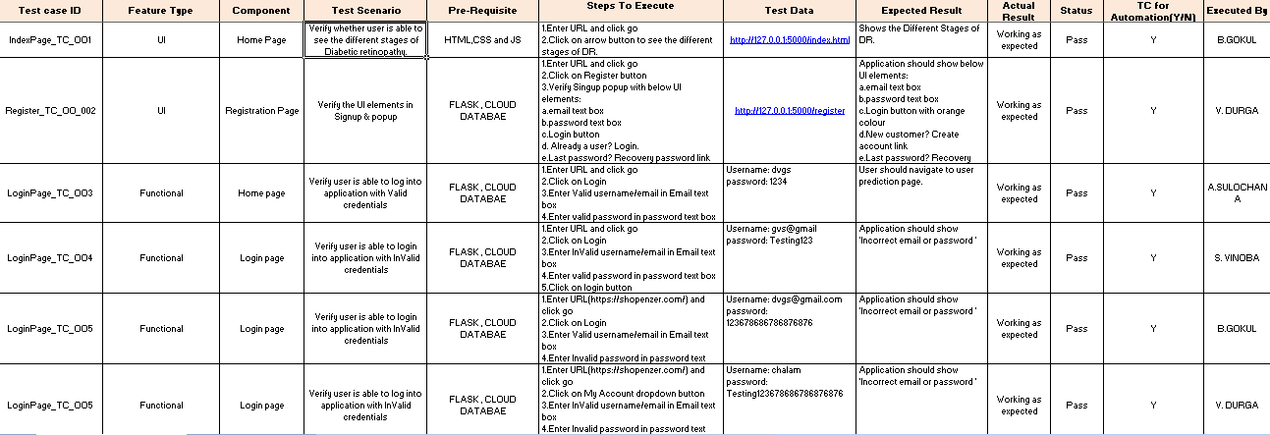

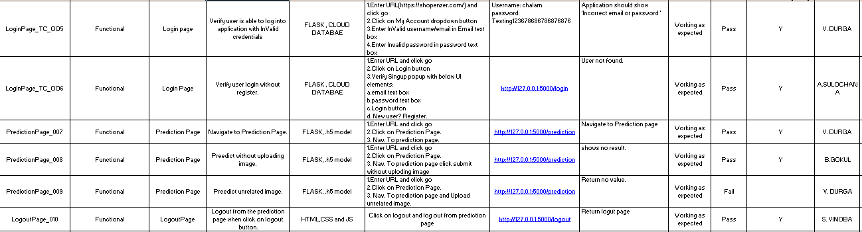

**8.2 User Acceptance Testing**

# Purpose of Document:-

This document serves as a quick reference for the Deep Learning Fundus Image Analysis for Early Detection of Diabetic Retinopathy project's test coverage and open issues as of the project's release for user acceptance testing.

# Defect Analysis:-

This shows how many bugs were fixed or closed at each severity level and how they were fixed.

|  |  |  |  |  |  |
| --- | --- | --- | --- | --- | --- |
| **Resolution** | **Severity 1** | **Severity 2** | **Severity 3** | **Severity 4** | **Subtotal** |
| By Design | 1 | 0 | 0 | 0 | 1 |
| Duplicate | 4 | 1 | 3 | 0 | 8 |
| External | 1 | 3 | 0 | 0 | 4 |
| Fixed | 2 | 4 | 4 | 2 | 12 |
| Not Reproduced | 0 | 0 | 0 | 1 | 1 |
| Skipped | 0 | 0 | 0 | 0 | 0 |
| Won't Fix | 0 | 0 | 0 | 0 | 0 |
| Totals | 8 | 8 | 4 | 2 | 22 |

# Test-Case Analysis

This report shows the number of test cases that have passed, failed, and untested.

|  |  |  |  |  |
| --- | --- | --- | --- | --- |
| **Section** | **Total Cases** | **Not Tested** | **Fail** | **Pass** |
| Print Engine | 5 | 0 | 0 | 5 |
| Client Application | 10 | 0 | 0 | 10 |
| Security | 2 | 0 | 0 | 2 |
| Out-source Shipping | 0 | 0 | 0 | 0 |
| Exception Reporting | 2 | 0 | 0 | 2 |
| Final Report Output | 4 | 0 | 0 | 4 |
| Version Control | 2 | 0 | 0 | 2 |

**RESULTS**

**9.1 Performance Metrics**

|  |  |  |  |
| --- | --- | --- | --- |
| **S.No.** | **Parameter** | **Values** | **Screenshot** |
|  | Model Summary | Total params: 21,885,485  Trainable params: 1,024,005  Non-trainable params: 20,861,480  __________________________________ |  |
|  | Accuracy | Training Accuracy **- 0.7500** Validation Accuracy -**loss 3.4420.** |  |
| 3. | Confidence Score (Only Yolo Projects) | Class Detected -   Confidence Score - | ------ |

**ADVANTAGES & DISADVANTAGES**

**ADVANTAGES**

* Profit sharing, by helping in public health care campaigns, with local hospitals
* Charging a very nominal amount for using the software at dispensaries.
* Predictions at the edge, their by **reducing money** spent on data **privacy concerns**.
* Less time consuming process.

**DISADVANTAGES**

* Sometime accuracy may loss.
* Prediction may go wrong.
* User may fell insecurity of data.

**CONCLUSION**

In this paper, we proposed the multistage transfer learning approach and an automatic method for detection of the stage of diabetic retinopathy by single photography of the human fundus. We have used an ensemble of 3 CNN architectures and made transfer learning for our final solution. The experimental results show that the proposed method achieves high and stable results even with unstable metric. The main advantage of this method is that it increases generalization and reduces variance by using an ensemble of the networks, pretrained on a large dataset, and finetuned on the target data set.

**FUTURE SCOPE**

* Deploy on edge devices
* Predict more than 5 stage diabetic retinopathy, like other biological conditions based on the retinal image.
* Split Learning and Differential Privacy to preserve privacy.
* Weak Supervision and Meta Learning algorithms can be used to deploy this for a larger set of images.

**APPENDIX**

**Source Code**

**Index.html**

<!DOCTYPE html>  
<html lang="en">  
<head>  
 <meta charset="UTF-8">  
 <title>index</title>  
 <link rel="stylesheet" href="..\static\css\indexstyle.css">  
</head>  
<body>  
 <div class="main">  
 <nav>  
 <div class ="logo">  
 <img src="..\static\images\img.png">  
 </div>  
 <div class="nav-links">  
 <ul>  
 <li><a href="index.html">Home</a></li>  
 <li><a href="login">Login</a></li>  
 <li><a href="register">Register</a></li>  
 <li><a href="prediction">Prediction</a></li>  
 </ul>  
 </div>  
 </nav>  
  
 <div class="information">  
 <div class="overlay"></div>  
 <img src="..\static\images\myproject.jpg" class="eye">  
 <div id="circle">  
 <div class="stages one">  
 <img src="..\static\images\text-1.png">  
 <div>  
 <h1>NPDR</h1>  
 <p>Mild Swelling in Retinal!</p>  
 </div>  
 </div>  
 <div class="stages two">  
 <img src="..\static\images\text-2.png">  
 <div>  
 <h1>Moderate NPDR</h1>  
 <p>NPDR plus small bleeds in Retinal!</p>  
 </div>  
 </div>  
 <div class="stages three">  
 <img src="..\static\images\text-3.png">  
 <div>  
 <h1>Severe NPDR</h1>  
 <p>Moderate NPDR plus further damage to<br>  
 blood vessels in Retinal!</p>  
 </div>  
 </div>  
 <div class="stages four">  
 <img src="..\static\images\text-4.png">  
 <div>  
 <h1>PDR</h1>  
 <p>Severe NPDR plus new Vessel<br>  
 formation in Retinal!</p>  
 </div>  
 </div>  
 </div>  
 </div>  
 <div class="coltrols">  
 <img src="..\static\images\arrow.png" id="upBtn">  
 <h3>Different Stages of DR</h3>  
 <img src="..\static\images\arrow.png" id="downBtn">  
 </div>  
  
 </div>  
 <script>  
 var circle = document.getElementById("circle");  
 var upBtn = document.getElementById("upBtn");  
 var downBtn = document.getElementById("downBtn");  
  
 var rotateValue = circle.style.transform;  
 var rotateSum;  
  
 upBtn.onclick = function()  
 {  
 rotateSum = rotateValue + "rotate(-90deg)";  
 circle.style.transform = rotateSum;  
 rotateValue = rotateSum;  
 }  
 downBtn.onclick = function()  
 {  
 rotateSum = rotateValue + "rotate(90deg)";  
 circle.style.transform = rotateSum;  
 rotateValue = rotateSum;  
 }  
 </script>  
  
</body>  
</html>

**Indexstyle.css**

*{  
 margin: 0;  
 padding: 0;  
 font-family: sans-serif;  
}  
.main{  
 width: 100%;  
 height: 100vh;  
 position: relative;  
 overflow: hidden;  
 background: linear-gradient(to right , #9c27b0, #8ecdff);  
}  
nav{  
 width: 80%;  
 position: sticky;  
 margin: 20px auto ;  
 z-index: 1;  
 display: flex;  
 align-items: center;  
}  
.logo{  
 flex-basis: 20%;  
}  
.logo img {  
 width: 450px;  
  
}  
.nav-links{  
 flex: 1;  
 text-align: right;  
}  
.nav-links ul li{  
 list-style: none;  
 display: inline-block;  
 margin: 0 20px;  
}  
.nav-links ul li a{  
 color: #FFE5B4;  
 text-decoration: none ;  
}  
.information{  
 width: 1000px;  
 height: 1000px;  
 position: absolute;  
 top: 50%;  
 left:-10%;  
 transform: translateY(-50%);  
}  
.information img{  
width:400px;  
left: 150px;  
top: 520px;  
}  
#circle{  
 width: 1000px;  
 height: 1000px;  
 position: absolute;  
 top: 0;  
 left: 0;  
 border-radius: 50%;  
 deansform: rotate(0deg);  
 transition: 1s;  
}  
.stages img{  
 width: 70px;  
}  
.stages{  
 position: absolute;  
 display: flex;  
 color: #fff;  
 font-style: bold;  
}  
.stages div {  
margin-left: 70px;  
}  
.stages div p{margin-top:8px;  
}  
.one{  
 top: 450px;  
 right: 50px;  
}  
.two{  
 top: 150px;  
 left: 300px;  
 transform: rotate(-90deg);  
}  
.three{  
 bottom: 450px;  
 left: -50px;  
 transform: rotate(-180deg);  
}  
.four{  
 bottom: 150px;  
 right: 300px;  
 transform: rotate(-270deg);  
}  
.eye{  
 width:200px;  
 position: absolute;  
 top: 50%;  
 left: 35%;  
 transform: translateY(-50%);  
 z-index: 1;  
}  
.coltrols {  
position: absolute;  
right: 10%;  
top: 50%;  
transform: translateY(-50%);  
text-align: center;  
}  
.coltrols h3{  
 margin: 15px 0;  
 color: #fff ;  
}  
#upBtn{  
 width: 15px;  
 cursor: pointer;  
}  
#downBtn{  
 width: 15px;  
 cursor: pointer;  
 transform: rotate(180deg);  
}  
.overlay{  
 width: 0;  
 height: 0;  
 border-top: 500px solid #fff;  
 border-right: 500px solid transparent;  
 border-bottom: 500px solid #fff;  
 border-left: 500px solid #fff;  
}

**Register.html**

<!DOCTYPE html>  
<html lang="en">  
<head>  
 <meta charset="UTF-8">  
 <title>Register</title>  
 <link href="..\static\css\RLStyle.css" rel="stylesheet">  
</head>  
<body><div class="hero">  
 <nav>  
 <div class ="logo">  
 <img src="..\static\images\img.png">  
 </div>  
 <div class="nav-links">  
 <ul>  
 <li><a href="index.html">Home</a></li>  
 <li><a href="login">Login</a></li>  
 </ul>  
 </div>  
 </nav>  
  
  
 <div class="information">  
 <div class="overlay"></div>  
 <img src="..\static\images\myproject.jpg" class="eye">  
 </div>  
  
  
  
 <div class="form-box">  
 <div class="button-box">  
 <div id="btn"></div>  
 <button type="button" class="toggle-btn" onclick="login()">Login</button>  
 <button type="button" class="toggle-btn" onclick="register()">Register</button>  
 </div>  
 <div class="social-icons">  
 <img src="..\static\images\fb.png">  
 <img src="..\static\images\gp.png">  
 <img src="..\static\images\tw.png">  
 </div>  
 <form action="afterlogin" method="post" id="Login" class="input-group">  
 <input type="email" class="input-field" name="_id" placeholder="Enter Email ID" required>  
 <input type="password" class="input-field" name="psw" placeholder="Enter Password" required>  
 <input type="checkbox" class="check-box"><span>Remember Password</span>  
 <button type="submit" class="submit-btn">Login</button>  
 {{pred}}  
 </form>  
 <form action="afterreg" method="post" id="Register" class="input-group">  
 <input type="text" class="input-field" name="name" placeholder="User Name " required>  
 <input type="email" class="input-field" name="_id" placeholder="Enter your Email" required>  
 <input type="password" class="input-field" name="psw" placeholder="Enter Password" required>  
 <input type="checkbox" class="check-box"><span>I agree to the terms and conditions</span>  
 <button type="submit" class="submit-btn">Register</button>  
 {{pred}}  
 </form>  
 </div>  
 </div>  
  
 <script>  
 var x = document.getElementById("Login");  
 var y = document.getElementById("Register");  
 var z = document.getElementById("btn");  
  
 function register(){  
 x.style.left = "-400px";  
 y.style.left = "50px";  
 z.style.left = "110px";  
 }  
 function login(){  
 x.style.left = "50px";  
 y.style.left = "450px";  
 z.style.left = "0";  
 }  
 </script>  
</body>  
</html>

**RLStyle.css**

*{  
 margin: 0;  
 padding: 0;  
 font-family: sans-serif;  
}  
.hero{  
 height: 100%;  
 width: 100%;  
 background-image: linear-gradient(to right , #9c27b0, #8ecdff);  
 background-position: center;  
 background-size: cover;  
 position: absolute;  
}  
nav{  
 width: 80%;  
 position: sticky;  
 margin: 20px auto ;  
 z-index: 1;  
 display: flex;  
 align-items: center;  
 }  
  
 .logo img {  
 width: 450px;  
 }  
  
  
.nav-links{  
 flex: 1;  
 text-align: right;  
}  
.nav-links ul li{  
 list-style: none;  
 display: inline-block;  
 margin: 0 20px;  
}  
.nav-links ul li a{  
 color: #FFE5B4;  
 text-decoration: none ;  
}  
  
.form-box{  
 width: 380px;  
 height: 480px;  
 position: relative;  
 margin-top: 80px;  
 margin-left:650px;  
  
 background: transparent;  
 padding: 5px;  
 border-radius: 30px;  
 overflow: hidden;  
 align: center;  
}  
.button-box{  
 width: 220px;  
 margin: 35px auto;  
 position: relative;  
 box-shadow: 0 0 20px 9px #ff61241f;  
 border-radius: 30px;  
}  
.toggle-btn{  
 padding: 10px 30px;  
 cursor: pointer;  
 background: transparent;  
 border: 0;  
 outline: none;  
 position: relative;  
}  
#btn{  
 top: 0;  
 left: 0;  
 position: absolute;  
 width: 110px;  
 height: 100%;  
 background: linear-gradient(to right, #ff105f,#ffad06);  
 border-radius: 30px;  
 transition: .5s;  
}  
.social-icons{  
 margin: 30px auto;  
 text-align: center;  
}  
.social-icons img{  
 width: 30px;  
 margin: 0 12px;  
 box-shadow: 0 0 20px 0 #7f7f7f3d;  
 cursor: pointer;  
 border-radius: 50%;  
}  
.input-group{  
 top: 180px;  
 position: absolute;  
 width: 280px;  
 transition: .5s;  
}  
.input-field{  
 width: 100%;  
 background: transparent;  
 border: 1px solid #fff;  
 margin: 6px 0;  
 height: 32px;  
 border-radius: 20px;  
 top: 15px;  
 padding: 0 10px;  
 box-sizing: border-box;  
 outline: none;  
 text-align: center;  
 color: #fff;  
}  
::placeholder{  
 color: #FFE5B4;  
 font-size: 12px;  
 }  
.submit-btn{  
 width: 85%;  
 padding: 10px 30px;  
 cursor: pointer;  
 display: block;  
 margin: auto;  
 background: linear-gradient(to right, #ff105f,#ffad06);  
 border: 0;  
 outline: none;  
 border-radius: 30px;  
}  
.check-box{  
 margin: 30px 10px 30px 0;  
 }  
span{  
 color: #fff;  
 font-size: 12px;  
 bottom: 68px;  
 position: absolute;  
}  
#Login{  
 left: 50px;  
}  
#Register{  
 left: 450px;  
}  
  
.information{  
 width: 1000px;  
 height: 1000px;  
 position: absolute;  
 top: 50%;  
 left:-10%;  
 transform: translateY(-50%);  
}  
.information img{  
width:400px;  
left: 150px;  
top: 520px;  
}  
  
.eye{  
 width:80px;  
 position: absolute;  
 top: 50%;  
 left: 35%;  
 transform: translateY(-50%);  
 z-index: 1;  
}  
.overlay{  
 width: 0;  
 height: 0;  
 border-top: 500px solid #fff;  
 border-right: 500px solid transparent;  
 border-bottom: 500px solid #fff;  
 border-left: 500px solid #fff;  
}

**Login.html**

<!DOCTYPE html>  
<html lang="en">  
<head>  
 <meta charset="UTF-8">  
 <title>Login</title>  
 <link href="..\static\css\RLStyle.css" rel="stylesheet">  
</head>  
  
<body><div class="hero">  
 <nav>  
 <div class ="logo">  
 <img src="..\static\images\img.png">  
 </div>  
 <div class="nav-links">  
 <ul>  
 <li><a href="index.html">Home</a></li>  
 <li><a href="register">Register</a></li>  
 </ul>  
 </div>  
 </nav>  
  
  
 <div class="information">  
 <div class="overlay"></div>  
 <img src="..\static\images\myproject.jpg" class="eye">  
 </div>  
  
  
 <div class="form-box">  
 <div class="button-box">  
 <div id="btn"></div>  
 <button type="button" class="toggle-btn" onclick="login()">Login</button>  
 <button type="button" class="toggle-btn" onclick="register()">Register</button>  
 </div>  
 <div class="social-icons">  
 <img src="..\static\images\fb.png">  
 <img src="..\static\images\gp.png">  
 <img src="..\static\images\tw.png">  
 </div>  
 <form action="afterlogin" method="post" id="Login" class="input-group">  
 <input type="email" class="input-field" name="_id" placeholder="Enter Email ID" required>  
 <input type="password" class="input-field" name="psw" placeholder="Enter Password" required>  
 <input type="checkbox" class="check-box"><span>Remember Password</span>  
 <button type="submit" class="submit-btn">Login</button>  
 {{pred}}  
 </form>  
 <form action="afterreg" method="post" id="Register" class="input-group">  
 <input type="text" class="input-field" name="name" placeholder="User Name " required>  
 <input type="email" class="input-field" name="_id" placeholder="Enter your Email" required>  
 <input type="password" class="input-field" name="psw" placeholder="Enter Password" required>  
 <input type="checkbox" class="check-box"><span>I agree to the terms and conditions</span>  
 <button type="submit" class="submit-btn">Register</button>  
 {{pred}}  
 </form>  
 </div>  
 </div>  
  
 <script>  
 var x = document.getElementById("Login");  
 var y = document.getElementById("Register");  
 var z = document.getElementById("btn");  
  
 function register(){  
 x.style.left = "-400px";  
 y.style.left = "50px";  
 z.style.left = "110px";  
 }  
 function login(){  
 x.style.left = "50px";  
 y.style.left = "450px";  
 z.style.left = "0";  
 }  
 </script>  
</body>  
</html>

**RLStyle.css**

*{  
 margin: 0;  
 padding: 0;  
 font-family: sans-serif;  
}  
.hero{  
 height: 100%;  
 width: 100%;  
 background-image: linear-gradient(to right , #9c27b0, #8ecdff);  
 background-position: center;  
 background-size: cover;  
 position: absolute;  
}  
nav{  
 width: 80%;  
 position: sticky;  
 margin: 20px auto ;  
 z-index: 1;  
 display: flex;  
 align-items: center;  
 }  
  
 .logo img {  
 width: 450px;  
 }  
  
  
.nav-links{  
 flex: 1;  
 text-align: right;  
}  
.nav-links ul li{  
 list-style: none;  
 display: inline-block;  
 margin: 0 20px;  
}  
.nav-links ul li a{  
 color: #FFE5B4;  
 text-decoration: none ;  
}  
  
.form-box{  
 width: 380px;  
 height: 480px;  
 position: relative;  
 margin-top: 80px;  
 margin-left:650px;  
  
 background: transparent;  
 padding: 5px;  
 border-radius: 30px;  
 overflow: hidden;  
 align: center;  
}  
.button-box{  
 width: 220px;  
 margin: 35px auto;  
 position: relative;  
 box-shadow: 0 0 20px 9px #ff61241f;  
 border-radius: 30px;  
}  
.toggle-btn{  
 padding: 10px 30px;  
 cursor: pointer;  
 background: transparent;  
 border: 0;  
 outline: none;  
 position: relative;  
}  
#btn{  
 top: 0;  
 left: 0;  
 position: absolute;  
 width: 110px;  
 height: 100%;  
 background: linear-gradient(to right, #ff105f,#ffad06);  
 border-radius: 30px;  
 transition: .5s;  
}  
.social-icons{  
 margin: 30px auto;  
 text-align: center;  
}  
.social-icons img{  
 width: 30px;  
 margin: 0 12px;  
 box-shadow: 0 0 20px 0 #7f7f7f3d;  
 cursor: pointer;  
 border-radius: 50%;  
}  
.input-group{  
 top: 180px;  
 position: absolute;  
 width: 280px;  
 transition: .5s;  
}  
.input-field{  
 width: 100%;  
 background: transparent;  
 border: 1px solid #fff;  
 margin: 6px 0;  
 height: 32px;  
 border-radius: 20px;  
 top: 15px;  
 padding: 0 10px;  
 box-sizing: border-box;  
 outline: none;  
 text-align: center;  
 color: #fff;  
}  
::placeholder{  
 color: #FFE5B4;  
 font-size: 12px;  
 }  
.submit-btn{  
 width: 85%;  
 padding: 10px 30px;  
 cursor: pointer;  
 display: block;  
 margin: auto;  
 background: linear-gradient(to right, #ff105f,#ffad06);  
 border: 0;  
 outline: none;  
 border-radius: 30px;  
}  
.check-box{  
 margin: 30px 10px 30px 0;  
 }  
span{  
 color: #fff;  
 font-size: 12px;  
 bottom: 68px;  
 position: absolute;  
}  
#Login{  
 left: 50px;  
}  
#Register{  
 left: 450px;  
}  
  
.information{  
 width: 1000px;  
 height: 1000px;  
 position: absolute;  
 top: 50%;  
 left:-10%;  
 transform: translateY(-50%);  
}  
.information img{  
width:400px;  
left: 150px;  
top: 520px;  
}  
  
.eye{  
 width:80px;  
 position: absolute;  
 top: 50%;  
 left: 35%;  
 transform: translateY(-50%);  
 z-index: 1;  
}  
.overlay{  
 width: 0;  
 height: 0;  
 border-top: 500px solid #fff;  
 border-right: 500px solid transparent;  
 border-bottom: 500px solid #fff;  
 border-left: 500px solid #fff;  
}

**Prediction.html**

<!DOCTYPE html>  
<html lang="en">  
<head>  
 <meta charset="UTF-8">  
 <meta http-equiv="X-UA-Compatible" content="IE=edge">  
 <meta name="viewport" content="width=device-width, initial-scale=1.0">  
 <!--Bootstrap -->  
 <link rel="stylesheet" href="https://maxcdn.bootstrapcdn.com/bootstrap/4.0.0/css/bootstrap.min.css" integrity="sha384-Gn5384xqQ1aoWXA+058RXPxPg6fy4IWvTNh0E263XmFcJlSAwiGgFAW/dAiS6JXm" crossorigin="anonymous">  
 <script src="https://code.jquery.com/jquery-3.2.1.slim.min.js" integrity="sha384-KJ3o2DKtIkvYIK3UENzmM7KCkRr/rE9/Qpg6aAZGJwFDMVNA/GpGFF93hXpG5KkN" crossorigin="anonymous"></script>  
 <script src="https://cdnjs.cloudflare.com/ajax/libs/popper.js/1.12.9/umd/popper.min.js" integrity="sha384-ApNbgh9B+Y1QKtv3Rn7W3mgPxhU9K/ScQsAP7hUibX39j7fakFPskvXusvfa0b4Q" crossorigin="anonymous"></script>  
 <script src="https://maxcdn.bootstrapcdn.com/bootstrap/4.0.0/js/bootstrap.min.js" integrity="sha384-JZR6Spejh4U02d8jOt6vLEHfe/JQGiRRSQQxSfFWpi1MquVdAyjUar5+76PVCmYl" crossorigin="anonymous"></script>  
  
  
 <script src="https://kit.fontawesome.com/8b9cdc2059.js" crossorigin="anonymous"></script>  
 <link href="https://fonts.googleapis.com/css2?family=Akronim&family=Roboto&display=swap" rel="stylesheet">  
  
  
 <link rel="stylesheet" href="..\static\css\prediction.css">  
  
 <script defer src="..\static\js\JScript.js"></script>  
  
  
 <title>prediction</title>  
</head>  
<body>  
<div class="main">  
 <nav>  
 <div class ="logo">  
 <img src="..\static\images\img_1.png">  
 </div>  
 <div class="nav-links">  
 <ul>  
 <li><a href="index.html">Home</a></li>  
 <li><a href="logout">Logout</a></li>  
 </ul>  
 </div>  
 </nav>  
  
 <!-- dataset/Training/metal/metal326.jpg -->  
 <section id="prediction">  
 <div class="prediction-input">  
 <div class="circle">  
 <img src="..\static\images\circle.jpg" alt="Demo" id="demo" class="circle">  
 </div>  
 <form id="form" action="/result" method="POST" enctype="multipart/form-data">  
 <input type="file" id="imageupload" name="image" accept="image/*" class="input-image">  
 <input type="submit" class="submitbtn">  
 </form>  
 </div>  
 <div class="content">  
 <h5>Diabetic Retinopathy Classification is : <b>{{prediction}}<b>  
 </h5>  
 </div>  
  
  
 <div class="line">  
 <img src="..\static\images\prediction.png" alt="">  
 </div>  
 </section>  
  
</div>  
</body>  
</html>

**Prediction.css**

*{  
 margin: 0;  
 padding: 0;  
 font-family: sans-serif;  
}  
  
.main{  
 width: 100%;  
 height: 100vh;  
 position: relative;  
 overflow: hidden;  
 background: linear-gradient(to right , #9c27b0, #8ecdff);  
}  
nav{  
 width: 80%;  
 position: sticky;  
 margin: 20px auto ;  
 z-index: 1;  
 display: flex;  
 align-items: center;  
}  
  
  
.logo img {  
 width: 550px;  
  
}  
.nav-links{  
 flex: 1;  
 text-align: right;  
}  
.nav-links ul li{  
 list-style: none;  
 display: inline-block;  
 margin: 0 20px;  
}  
.nav-links ul li a{  
 color: #FFE5B4;  
 text-decoration: none ;  
 margin-top: -10px;  
}  
#prediction .prediction-input{  
 display: flex;  
 align-items: center;  
 justify-content: center;  
 margin-top: 1.5rem;  
}  
#prediction .prediction-input form{  
 margin-left: 1.2rem;  
}  
#prediction .circle {  
 width: 150px;  
 height: 150px;  
 border-radius: 50%;  
 margin-bottom: 5px;  
 box-shadow:var(--box-shadow);  
 transition:all ease-in 1s;  
}  
  
.output{  
 width: 200px;  
 margin: 10rem 1.5rem;  
 padding: 6px;  
 text-align: center;  
 box-shadow: rgba(0, 0, 0, 0.35) 0px 5px 15px;  
}  
.output-container{  
 display: grid;  
 row-gap: 10px;  
 grid-template-areas: 'img1 img2 img3 img4 img5 img6';  
}  
  
/* Hidden class */  
.hidden{  
 visibility: hidden;  
}  
.hide{  
 visibility: hidden;  
}  
.line img{  
width: 500px;  
position: relative;  
margin-left: 400px;  
}  
  
.content h5{  
 font-size: 15px;  
 margin-left: 400px;  
 font-style: italic;  
 color: white;  
 font-weight: bolder;  
 color: #fff;  
}

**Logout.html**

<!DOCTYPE html>  
<html lang="en">  
<head>  
 <meta charset="UTF-8">  
 <title>Logout</title>  
 <link rel="stylesheet" href="..\static\css\logout.css">  
</head>  
<body>  
 <div class="main">  
 <nav>  
 <div class ="logo">  
 <img src="..\static\images\img.png">  
 </div>  
 <div class="nav-links">  
 <ul>  
 <li><a href="index.html">Home</a></li>  
 <li><a href="login">Login</a></li>  
 </ul>  
 </div>  
 </nav>  
  
  
 <div class="information">  
 <div class="overlay"></div>  
 <img src="..\static\images\myproject.jpg" class="eye">  
 </div>  
  
 <div class="content">  
 <h1>Logged Out sucessfull</h1>  
 <p>Login for more details</p>  
 </div>  
 </div>  
  
</body>  
</html>

**Logout.css**

*{  
 margin: 0;  
 padding: 0;  
 font-family: sans-serif;  
}  
.main{  
 width: 100%;  
 height: 100vh;  
 position: relative;  
 overflow: hidden;  
 background: linear-gradient(to right , #9c27b0, #8ecdff);  
}  
nav{  
 width: 80%;  
 position: sticky;  
 margin: 20px auto ;  
 z-index: 1;  
 display: flex;  
 align-items: center;  
 }  
  
  
 .logo img {  
 width: 450px;  
 }  
  
  
 .nav-links{  
 flex: 1;  
 text-align: right;  
}  
.nav-links ul li{  
 list-style: none;  
 display: inline-block;  
 margin: 0 20px;  
}  
.nav-links ul li a{  
 color: #FFE5B4;  
 text-decoration: none ;  
}  
.content h1{  
 font-size: 50px;  
 margin-top: 250px;  
 margin-left: 550px;  
 font-style: italic;  
 color: white;  
 font-weight: bolder;  
 color: #fff;  
}  
.content p{  
 margin: 20px auto;  
 font-weight: 200;  
 line-height: 25px;  
 font-size: 20px;  
 margin-left: 250px;  
 text-align: center;  
 color:#FFE5B4 ;  
 }  
  
.information{  
 width: 1000px;  
 height: 1000px;  
 position: absolute;  
 top: 50%;  
 left:-10%;  
 transform: translateY(-50%);  
}  
.information img{  
width:400px;  
left: 150px;  
top: 520px;  
}  
  
.eye{  
 width:80px;  
 position: absolute;  
 top: 50%;  
 left: 35%;  
 transform: translateY(-50%);  
 z-index: 1;  
}  
.overlay{  
 width: 0;  
 height: 0;  
 border-top: 500px solid #fff;  
 border-right: 500px solid transparent;  
 border-bottom: 500px solid #fff;  
 border-left: 500px solid #fff;  
}

**Jscript.js**

'use strict'  
const demo = document.querySelector('#demo');  
const imageUpload = document.getElementById('imageupload');  
const dataAttributeEL = document.querySelectorAll(`div[data-type]`);  
const displayAll = function () {  
 dataAttributeEL.forEach(el => {  
 el.classList.remove('hidden')  
 })  
}  
  
  
imageUpload.addEventListener('change', (event) => {  
 const fileList = event.target.files[0];  
  
 //console.log(URL.createObjectURL(fileList));  
 if (fileList) {  
 demo.src =URL.createObjectURL(fileList);  
 }  
 displayAll();  
  
});  
  
const prediction = document.querySelector('#result')  
dataAttributeEL.forEach(el => {  
 if (el.dataset.type !== prediction.innerHTML.trim()) {  
 el.classList.add('hidden')  
 };  
})

**app.py**

import numpy as np  
import os  
from tensorflow.keras.models import load_model  
from tensorflow.keras.preprocessing import image  
from tensorflow.keras.applications.inception_v3 import preprocess_input  
import requests  
  
from flask import Flask, request, render_template, redirect, url_for  
  
from cloudant.client import Cloudant  
  
client = Cloudant.iam('eaea0c4d-acdc-48ac-a4c5-dacf9847810f-bluemix','nAoFO-_pU1j297US860S3RUPuYvBbqwn6KJvKphIkjZc',connect=True)  
  
my_database = client.create_database('my_database')  
  
model = load_model("model/updated-xecption-deiabetic-retinopathy (1).h5")  
app = Flask(__name__)  
  
  
@app.route('/')  
def index():  
 return render_template('index.html')  
  
@app.route('/index.html')  
def home():  
 return render_template('index.html')  
  
  
@app.route('/register')  
def register():  
 return render_template('register.html')  
  
@app.route('/afterreg', methods=['POST'])  
def afterreg():  
 x= [x for x in request.form.values() ]  
 print(x)  
 data = {  
 '_id': x[1],  
 'name': x[0],  
 'psw': x[2]  
 }  
 print(data)  
  
 query = {'_id': {'Seq': data['_id']}}  
  
 docs = my_database.get_query_result(query)  
 print(docs)  
  
 print(len(docs.all()))  
  
 if(len(docs.all())==0):  
 url = my_database.create_document(data)  
 #response = requests.get(url)  
 return render_template('register.html',pred="Registration Successfull, Please login using your details")  
 else:  
 return render_template('register.html', pred="You are already a member, please login using your details")  
  
  
@app.route('/login')  
def login():  
 return ( render_template('login.html'))  
  
@app.route('/afterlogin',methods=['POST'])  
def afterlogin():  
 user = request.form['_id']  
 passw = request.form['psw']  
 print(user,passw)  
  
 query = {'_id': {'$eq': user}}  
  
 docs = my_database.get_query_result(query)  
 print(docs)  
  
 print(len(docs.all()))  
  
 if(len(docs.all())==0):  
 return render_template('login.html', pred='The Username is not found.')  
 else:  
 if ((user==docs[0][0]['_id'] and passw==docs[0][0]['psw'])):  
 return render_template('prediction.html')  
 else:  
 print('Invalid User')  
  
  
@app.route('/logout')  
def logout():  
 return render_template('logout.html')  
  
@app.route('/prediction')  
def prediction():  
 return render_template('prediction.html')  
  
  
@app.route('/result',methods=["GET","POST"])  
def res():  
 if request.method=="POST":  
 f=request.files['image']  
 basepath=os.path.dirname(__file__)  
 filepath=os.path.join(basepath,'uploads',f.filename)  
 f.save(filepath)  
  
 img=image.load_img(filepath,target_size=(299,299))  
 x=image.img_to_array(img)  
 x=np.expand_dims(x,axis=0)  
 #print(x)  
 img_data=preprocess_input(x)  
 prediction=np.argmax(model.predict(img_data),axis=1)  
  
 index=['No Diabetic Retinopathy','Mild DR','Moderate DR','Sever DR','Proliferative DR']  
  
 result = str(index[prediction[0]])  
 return render_template('prediction.html',prediction=result)  
  
  
  
if __name__ == "__main__" :  
 app.run(debug=False)

**GitHub & Project Demo Link**

[**https://github.com/IBM-EPBL/IBM-Project-54108-1661597230**](https://github.com/IBM-EPBL/IBM-Project-54108-1661597230)

**project demo Link**

[**https://youtu.be/X-76U1HwXU0**](https://youtu.be/X-76U1HwXU0)